Dimensions
# Source: AI Source: Provided by: [Data Path: Persons Table -> ID Column: 1, Name_En Column: Motasem Essam] -> From: [ChatGPT] on [7/17/2026]
Dimensions are the fundamental physical characteristics used to describe the nature of a physical quantity. They indicate what kind of quantity is being measured (such as length, mass, or time), independent of the units used (such as meters, kilograms, or seconds).
Dimensions are the foundation of Dimensional Analysis, allowing scientists and engineers to verify equations, derive formulas, and understand relationships between physical quantities.

Definition
# Source: AI Source: Provided by: [Data Path: Persons Table -> ID Column: 1, Name_En Column: Motasem Essam] -> From: [ChatGPT] on [7/17/2026]
Dimensions are symbolic representations of the fundamental physical quantities from which all other physical quantities are derived.

Purpose
# Source: AI Source: Provided by: [Data Path: Persons Table -> ID Column: 1, Name_En Column: Motasem Essam] -> From: [ChatGPT] on [7/17/2026]
Dimensions are used to:
- Describe the physical nature of quantities.
- Verify the correctness of physical equations.
- Derive relationships between variables.
- Perform dimensional analysis.
- Distinguish different types of physical quantities.

Characteristics
# Source: AI Source: Provided by: [Data Path: Persons Table -> ID Column: 1, Name_En Column: Motasem Essam] -> From: [ChatGPT] on [7/17/2026]
Dimensions:
- Represent the type of physical quantity.
- Are independent of measurement units.
- Are written using symbols enclosed in square brackets.
- Form the basis for derived quantities.
- Remain the same regardless of the measurement system.

Fundamental Dimensions

Seven Fundamental Dimensions
# Source: AI Source: Provided by: [Data Path: Persons Table -> ID Column: 1, Name_En Column: Motasem Essam] -> From: [ChatGPT] on [7/17/2026]
The International System of Units (SI) is based on seven fundamental dimensions.
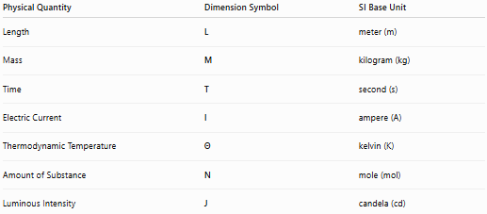
Physical Quantity | Dimension Symbol | SI Base Unit
Length | L | meter (m)
Mass | M | kilogram (kg)
Time | T | second (s)
Electric Current | I | ampere (A)
Thermodynamic Temperature | Θ | kelvin (K)
Amount of Substance | N | mole (mol)
Luminous Intensity | J | candela (cd)

Derived Dimensions
# Source: AI Source: Provided by: [Data Path: Persons Table -> ID Column: 1, Name_En Column: Motasem Essam] -> From: [ChatGPT] on [7/17/2026]
Most physical quantities are combinations of the fundamental dimensions.
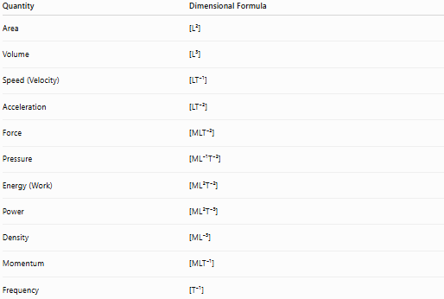
Quantity | Dimensional Formula
Area | [L²]
Volume | [L³]
Speed (Velocity) | [LT⁻¹]
Acceleration | [LT⁻²]
Force | [MLT⁻²]
Pressure | [ML⁻¹T⁻²]
Energy (Work) | [ML²T⁻²]
Power | [ML²T⁻³]
Density | [ML⁻³]
Momentum | [MLT⁻¹]
Frequency | [T⁻¹]

Examples
# Source: AI Source: Provided by: [Data Path: Persons Table -> ID Column: 1, Name_En Column: Motasem Essam] -> From: [ChatGPT] on [7/17/2026]
Length
Dimension:
$$\left[L\right]$$
Unit:
meter (m)

Area
Area = Length × Length
Dimension:
$$\left[L^{2}\right]$$
Unit:
square meter (m²)

Volume
Volume = Length × Length × Length
Dimension:
$$\left[L^{3}\right]$$
Unit:
cubic meter (m³)

Speed
Speed = Distance / Time
Dimension:
$$\frac{L}{T}=LT^{-1}$$
Unit:
m/s

Acceleration
Acceleration = Speed / Time
Dimension:
$$LT^{-2}$$
Unit:
m/s²

Force
Force = Mass × Acceleration
Dimension:
$$M×LT^{-2}=MLT^{-2}$$
Unit:
newton (N)

Pressure
Pressure = Force / Area
Dimension:
$$\frac{MLT^{-2}}{L^{2}}=ML^{-1}T^{-2}$$
Unit:
pascal (Pa)

Density
Density = Mass / Volume
Dimension:
$$\frac{M}{L^{3}}=ML^{-3}$$
Unit:
kg/m³

Energy
Energy = Force × Distance
Dimension:
$$MLT^{-2}×L=ML^{2}T^{-2}$$
Unit:
joule (J)

Power
Power = Energy / Time
Dimension:
$$\frac{ML^{2}T^{-2}}{T}=ML^{2}T^{-3}$$
Unit:
watt (W)

Dimensional Formula
# Source: AI Source: Provided by: [Data Path: Persons Table -> ID Column: 1, Name_En Column: Motasem Essam] -> From: [ChatGPT] on [7/17/2026]
A dimensional formula expresses a quantity using powers of the fundamental dimensions.
Examples:
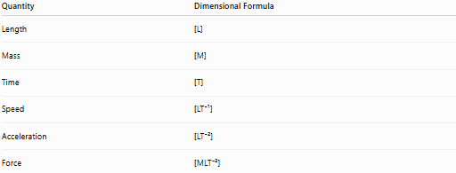
Quantity | Dimensional Formula
Length | [L]
Mass | [M]
Time | [T]
Speed | [LT⁻¹]
Acceleration | [LT⁻²]
Force | [MLT⁻²]

Dimensions vs. Units
# Source: AI Source: Provided by: [Data Path: Persons Table -> ID Column: 1, Name_En Column: Motasem Essam] -> From: [ChatGPT] on [7/17/2026]
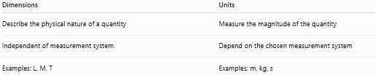
Dimensions | Units
Describe the physical nature of a quantity | Measure the magnitude of the quantity
Independent of measurement system | Depend on the chosen measurement system
Examples: L, M, T | Examples: m, kg, s
Example:
Length
Dimension:
[L]
Possible units:
- meter (m)
- centimeter (cm)
- foot (ft)
- inch (in)
The dimension remains L regardless of the unit.

Applications
# Source: AI Source: Provided by: [Data Path: Persons Table -> ID Column: 1, Name_En Column: Motasem Essam] -> From: [ChatGPT] on [7/17/2026]
Dimensions are used in:
- Physics
- Engineering
- Chemistry
- Fluid mechanics
- Thermodynamics
- Electromagnetism
- Astronomy
- Scientific research
- Mathematical modeling
- Dimensional analysis

Importance
# Source: AI Source: Provided by: [Data Path: Persons Table -> ID Column: 1, Name_En Column: Motasem Essam] -> From: [ChatGPT] on [7/17/2026]
Dimensions:
- Verify equations.
- Detect errors.
- Simplify derivations.
- Help derive physical relationships.
- Ensure scientific consistency.

Common Mistakes
# Source: AI Source: Provided by: [Data Path: Persons Table -> ID Column: 1, Name_En Column: Motasem Essam] -> From: [ChatGPT] on [7/17/2026]
- Confusing dimensions with units.
- Assuming identical dimensions always mean identical physical quantities (for example, work and torque both have dimensions [ML²T⁻²] but represent different concepts).
- Forgetting exponent rules.
- Ignoring derived dimensions.

Key Points
# Source: AI Source: Provided by: [Data Path: Persons Table -> ID Column: 1, Name_En Column: Motasem Essam] -> From: [ChatGPT] on [7/17/2026]
- Dimensions describe the physical nature of quantities.
- They are independent of units.
- The seven SI fundamental dimensions are:
  - L – Length
  - M – Mass
  - T – Time
  - I – Electric Current
  - Θ – Temperature
  - N – Amount of Substance
  - J – Luminous Intensity
- Derived quantities combine these dimensions algebraically.
- Dimensions are essential for Dimensional Analysis and equation verification.

Conclusion
# Source: AI Source: Provided by: [Data Path: Persons Table -> ID Column: 1, Name_En Column: Motasem Essam] -> From: [ChatGPT] on [7/17/2026]
Dimensions are symbolic representations of the fundamental physical nature of measurable quantities. They provide a universal way to describe quantities independently of the units used and form the basis for all derived physical quantities. By expressing relationships such as speed [LT⁻¹], force [MLT⁻²], and energy [ML²T⁻²], dimensions enable scientists and engineers to verify equations, derive formulas, detect inconsistencies, and ensure that physical relationships are mathematically and scientifically valid.

